“Colegio Salesiano Santa Cecilia”



“Aerocontrol”

**Computing System and Technical English**

Students:

-Bonilla Bonilla, Ted Gabriel #3

-Meléndez Hernández, Diego Ronaldo #17

Teachers:

José Felix Sinto Masin.

Index

Introduction i

Objectives ii

Project Description 1

Conclusions 3

Attachments 4

Glossary 4

Budget 6

Schedule 7

Screenshots 8

Presentation Cards 13

Brochure 14

Banner 15

Acknowledgement 16

Introduction

The following report contains all the information of the project AeroControl, the objectives, the technical detail and the description of the project, also the advantages and achieves that have in which explain the programming language at the time it’s been developing, and all the things that the group have decided to use for the creation of this platform.

Objectives

General Objective.

To develop a platform web that will make reservations and will have a support for an airline.

Specific Objectives.

-To code a Web application with a design and interactive interface.

-To Develop the platform with efficiently in the stablish time.

Project Description

The Project consist on the creation of a platform web for different Airlines that work together to offer their services to the clients, and the clients to have a better experience on flights.

In the platform we can watch the flights in real time that all the users can see it for but for make reservations for tickets first the user have to register on the platform. Also part of the user client have a place to search for specific flight, and have calendar that can see the description of all the flights.

The administrator have all the functions of the maintenances and also can post flights and have the list of the personal of the airline.

Also the platform contains a maintenance for each airline that can post flights and control of all the flights, and all their planes.

This Project it’s been developing in language code PHP, also includes Bootstrap and a little of JavaScript, and MySQL for database.

Modules

**Administrator:** This type of module have all the actions inside the platform, it can inter flights, sign up Airlines, users. Clients, etc. This manage all the system from its own platform.

**User Client:** This type of module only have the option to buy flights and see the different destinations.



**Airline:** The Airlines have the option to post their flights, and post the promotions that have inside the platform.

Conclusions

AeroControl was made with the purpose of made that many companies work together, and offer their services to their clients and have a better and easy way to buy flights. The platform was developed as hardly for the airlines and the clients that interest to fly. It was made for the users to want to want an easy way to buy tickets for flights.

Finally, after all the modifications, the project group has concluded that the word of airlines bigger than we think, and also based on was each person was looking for buy a flight.

What the user really needs and benefits him for the way to find what they want. The group conclude that the aspects as flights are see it from all the modules are more profitable applications and the more useful ones for the project.

Attachments

Glossary

Airline: An organization that provides air transportation for passengers and freight.

Airplane: Any of various winged vehicles capable of flight, generally heavier than air and driven by jet engines or propellers.

Airports: a tract of land or water with facilities for the landing, takeoff, shelter, supply, and repair of aircraft, especially one used for receiving or discharging passengers and cargo at regularly scheduled times.

Staff: a group of persons, as employees, charged with carrying out the work of an establishment or executing some undertaking.

Flight: The motion of an object in or through a medium, especially through the earth's atmosphere or through space.

Destinations: the place to which a person or thing travels or is sent.

Tickets: a slip, usually of pap.er or cardboard, serving as evidence that the holder has paid a fare or admission or is entitled to some service, right, or the like.

Client: A customer or patron.

Calendar: a table or register with the days of each month and week in a year.

Administrator: One who administers, especially one who works as a manager in a business, government agency, or school.

Stewardess: A woman/man flight attendant.

Passport: An official document issued by a government identifying a citizen, certifying his or her nationality, and formally requesting admittance and safe passage from foreign countries.

Seats: something designed to support a person in a sitting position, as a chair, bench, or pew; a place on or in which one sits.

Zip: to travel with a sharp hissing or humming sound.

Runways: A strip of level, usually paved ground on which aircraft take off and land.

Location: a place of settlement, activity, or residence.

Aircraft: is a machine that is able to fly by gaining support from the air, or, in general, the atmosphere of a planet.

Cost: An amount paid or required in payment for a purchase; a price.

State: The supreme public power within a sovereign political entity.

Database: is an organized collection of data.

PHP : is a script language and interpreter that is freely available

Budget

The project have a general budget of the things that are going to be spend.

|  |  |  |  |
| --- | --- | --- | --- |
| **Budget** | | | |
| **Material** | **Unit Price** | **Amount** | **Total** |
| Papers | $3.00 | 2 | $6.00 |
| Print | $2.00 | 5 | $10.00 |
| Transport | $4.00 | 5 | $20.00 |
| Electric Power | $5.00 | 3 | $15.00 |
| Banner | $10.00 | 1 | $10.00 |
| Brochures | $4.00 | 2 | $8.00 |
| Assessor | $5.00 | 4 | $20.00 |
| **Total** | | **22** | **$89.00** |

|  |  |  |  |  |  |  |  |  |  |  |  |  |  |  |  |  |  |  |  |  |  |  |  |  |  |  |  |  |  |  |  |
| --- | --- | --- | --- | --- | --- | --- | --- | --- | --- | --- | --- | --- | --- | --- | --- | --- | --- | --- | --- | --- | --- | --- | --- | --- | --- | --- | --- | --- | --- | --- | --- |
| **No.** | **Month** | **February** | | | | | **March** | | | | | **April** | | | | | **May** | | | | | **June** | | | | | **July** | | | | |
|  | **Activities / Week** | **1** | **2** | **3** | **4** | **5** | **1** | **2** | **3** | **4** | **5** | **1** | **2** | **3** | **4** | **5** | **1** | **2** | **3** | **4** | **5** | **1** | **2** | **3** | **4** | **5** | **1** | **2** | **3** | **4** | **5** |
| **1** | Due date for written report Spanish |  |  |  |  |  |  |  |  |  |  |  |  |  |  |  |  |  |  |  |  |  |  |  |  |  |  |  |  |  |  |
| **2** | Due date for written report English |  |  |  |  |  |  |  |  |  |  |  |  |  |  |  |  |  |  |  |  |  |  |  |  |  |  |  |  |  |  |
| **3** | English presentation of the first advance of the PTC |  |  |  |  |  |  |  |  |  |  |  |  |  |  |  |  |  |  |  |  |  |  |  |  |  |  |  |  |  |  |
| **4** | Team Reunion |  |  |  |  |  |  |  |  |  |  |  |  |  |  |  |  |  |  |  |  |  |  |  |  |  |  |  |  |  |  |
| **5** | Team Reunion |  |  |  |  |  |  |  |  |  |  |  |  |  |  |  |  |  |  |  |  |  |  |  |  |  |  |  |  |  |  |
| **6** | Team Reunion |  |  |  |  |  |  |  |  |  |  |  |  |  |  |  |  |  |  |  |  |  |  |  |  |  |  |  |  |  |  |
| **7** | Written Report of the advance of the PTC English |  |  |  |  |  |  |  |  |  |  |  |  |  |  |  |  |  |  |  |  |  |  |  |  |  |  |  |  |  |  |
| **8** | English presentation of the 50% of the PTC |  |  |  |  |  |  |  |  |  |  |  |  |  |  |  |  |  |  |  |  |  |  |  |  |  |  |  |  |  |  |
| **9** | Spanish report of the PTC |  |  |  |  |  |  |  |  |  |  |  |  |  |  |  |  |  |  |  |  |  |  |  |  |  |  |  |  |  |  |
| **10** | Written Memory of the PTC |  |  |  |  |  |  |  |  |  |  |  |  |  |  |  |  |  |  |  |  |  |  |  |  |  |  |  |  |  |  |
| **11** | Semana de Juventud |  |  |  |  |  |  |  |  |  |  |  |  |  |  |  |  |  |  |  |  |  |  |  |  |  |  |  |  |  |  |

Schedule

Screenshots

This is the login and the register section this is one of the most important because here you enter to the platform.

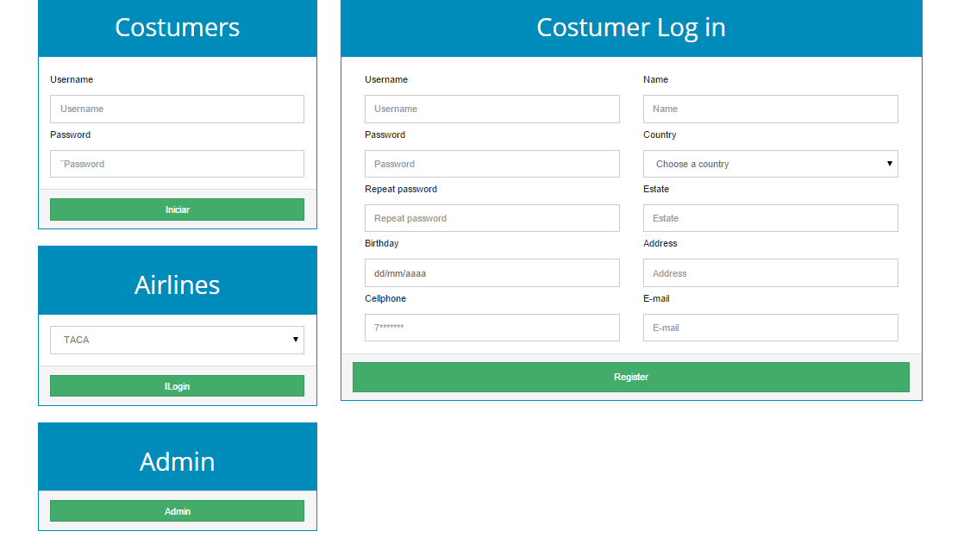

Here you can see all the flights in real time that are available to buy for the user.

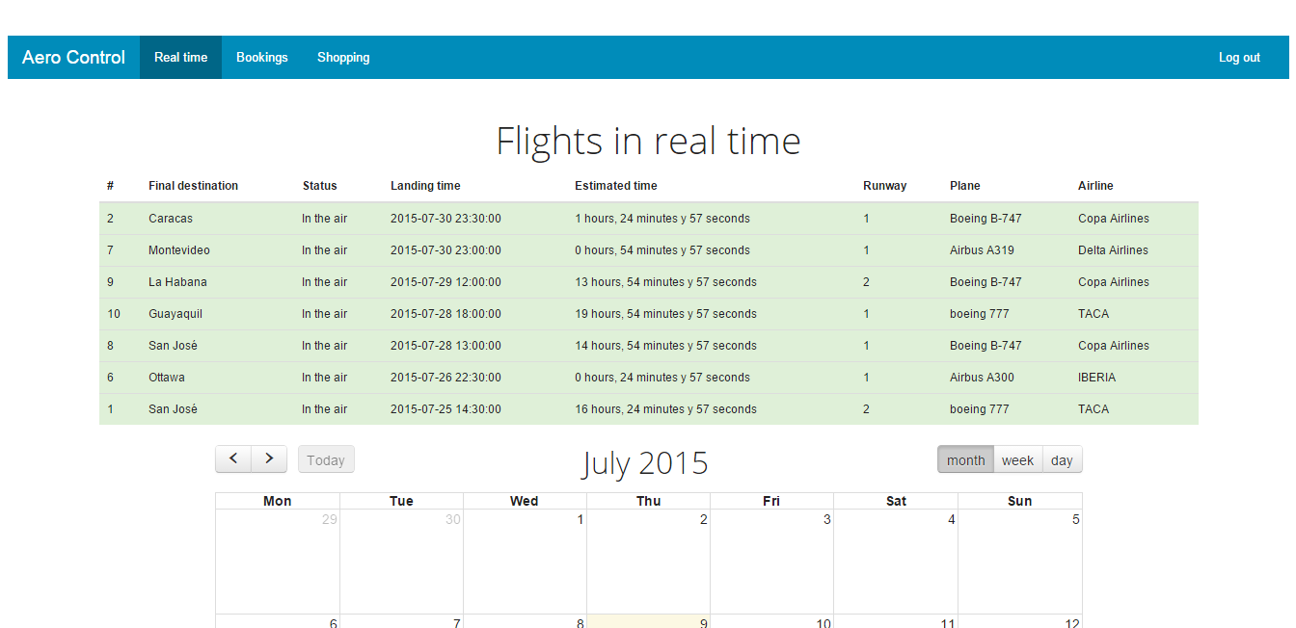

Also we can see a calendar with a description and the departure date of the flights.

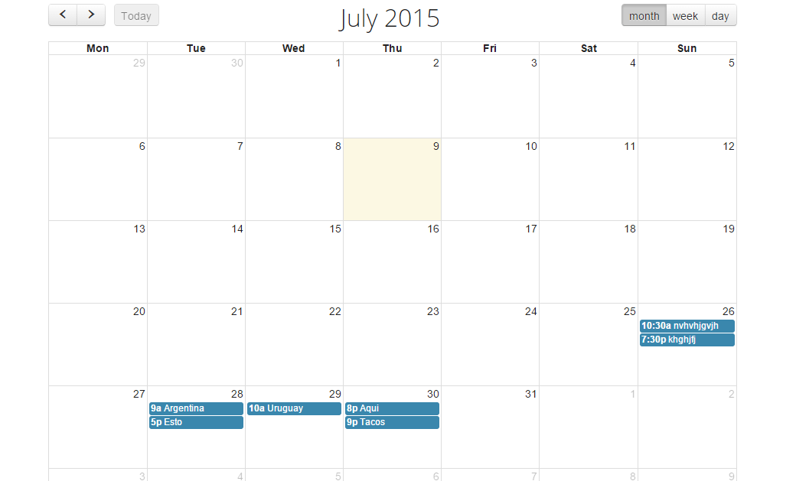

In the part of booking we can search for your preference to all the flights that are available to buy.

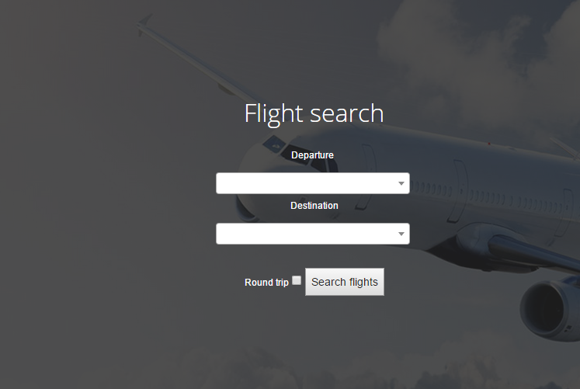

You have to different types for search.

The first is just buying tickets just to go.

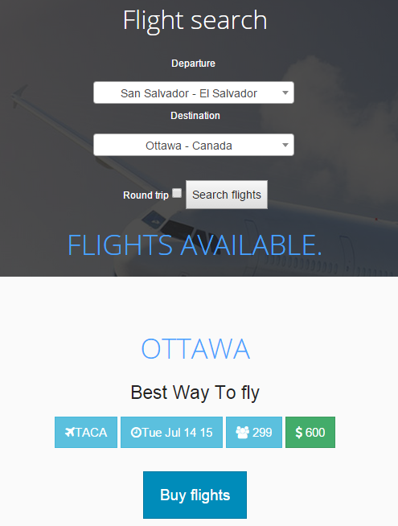

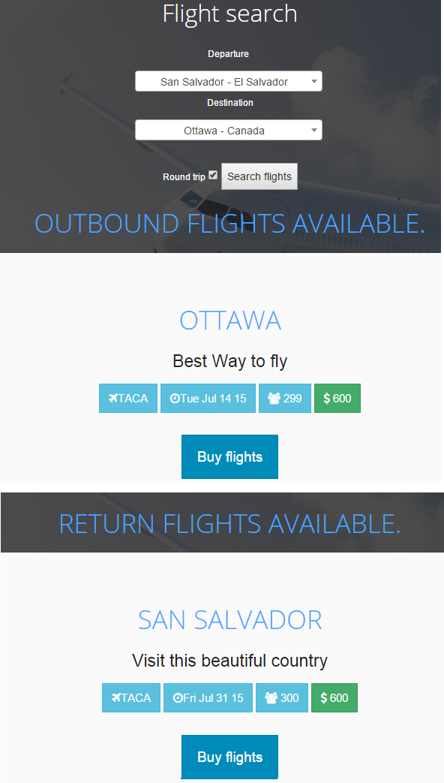The second is just buying tickets just to go and come back from the country.

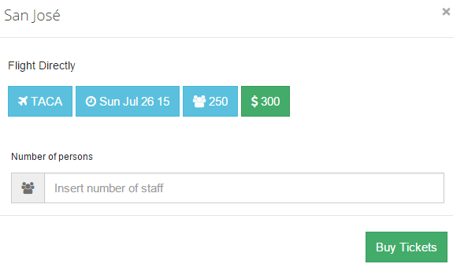When you want to buy tickets it will appear this form that you have to complete.

Presentation Cards

 

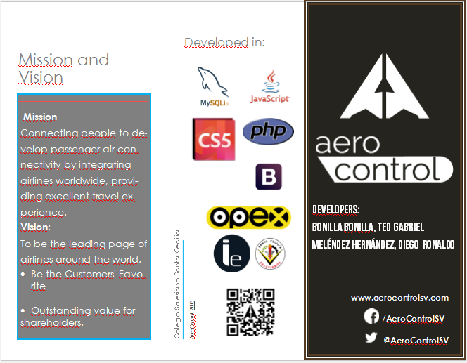Brochure­­­

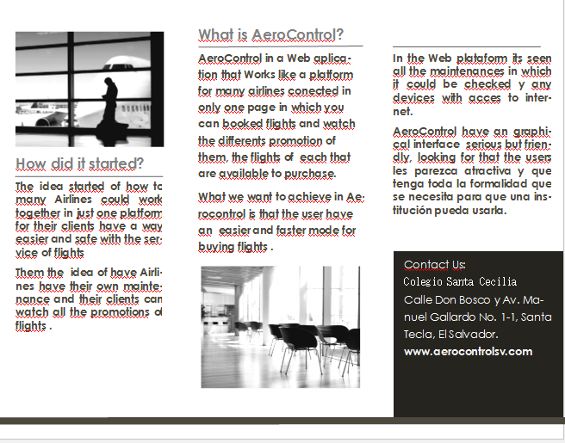

Banner

Acknowledgement

The present Project was developed under the supervision of Teacher Maira Beltrán and Lic. Felix Sinto, to express our gratitude for brig us the opportunity to work under their supervision on our project. Thanks for all the support, suggestions, and dedications it could be possible the early termination of this project. Definitely also be our guides of high school, they are wonderful humans that deserved all our respect and sincerity in all moment.

Thanks to God and our parents to give us an opportunity of study in a prestigious school. For the confidence that deposited in us and for unconditional love.

Our heartfelt thanks to all people that help one way or another in our academic education.